**COSC363 Assignment 1 Report**

**The Scene**

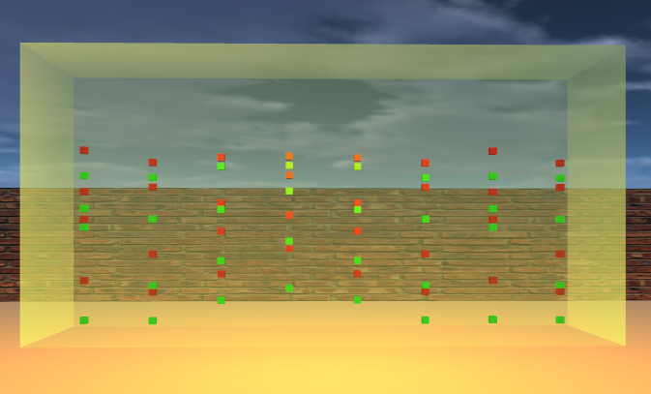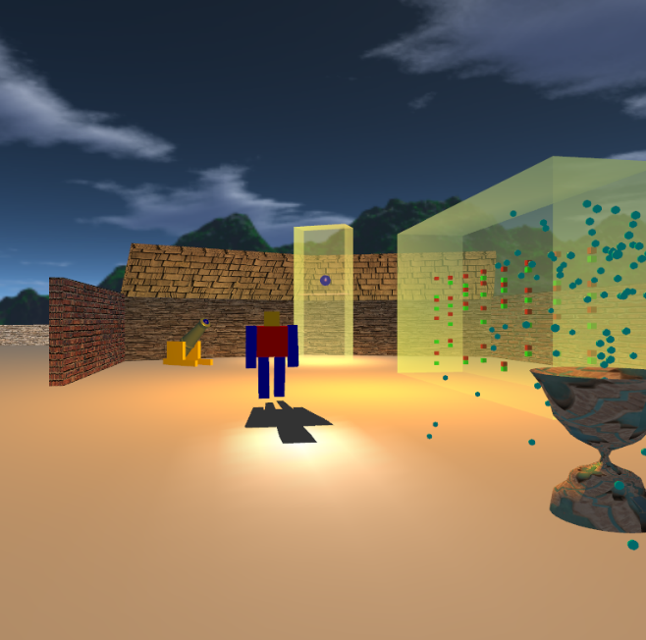(narrator) The life of a museum guard is an easy life. (museum guard) “All I do is walk around some priceless science based objects all day, making sure nothing bad happens”. (narrator) He soon finds out that his job is in jeopardy when something unexpected happens by the cannon one fateful day.

Figure 2: ‘Gravitational less’ cabinet which contains 8x8 cubes, each with infinite oscillation

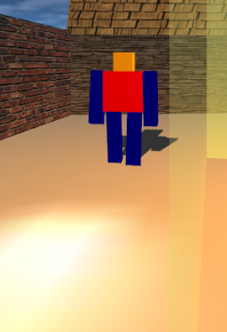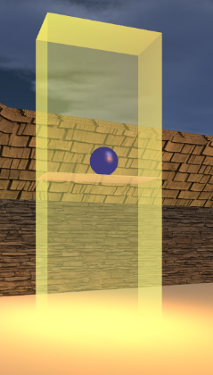

Figure 1: Overview

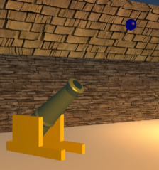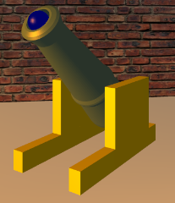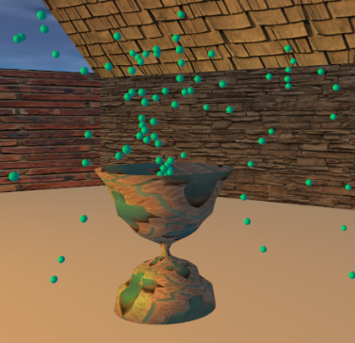

Figure 3: Cannon – stationary and non

Figure 6: Guard – with flashlight and shadow

Figure 5: Magic bouncy ball

Figure 4: Soapy fountain

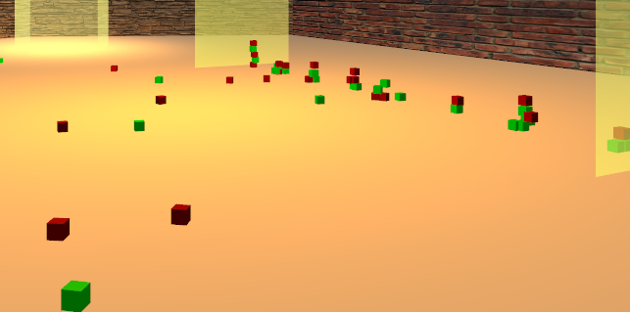

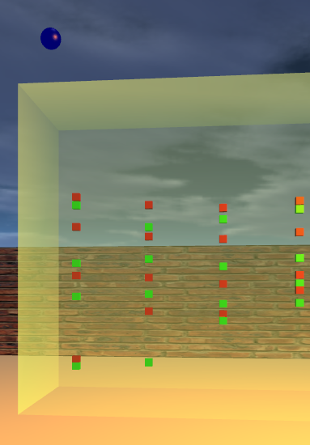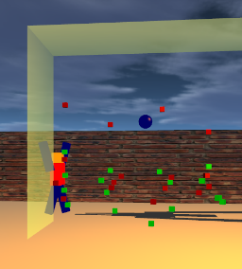

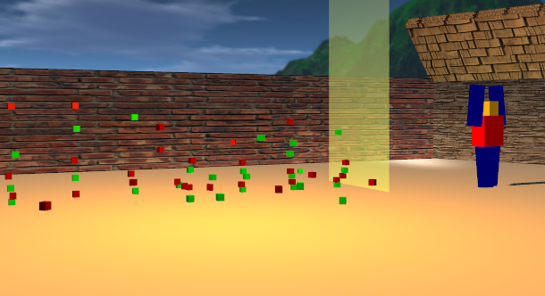

Figure(s) 7: Cannon ball breaking gravitational less cabinet – cubes are subjected to gravity

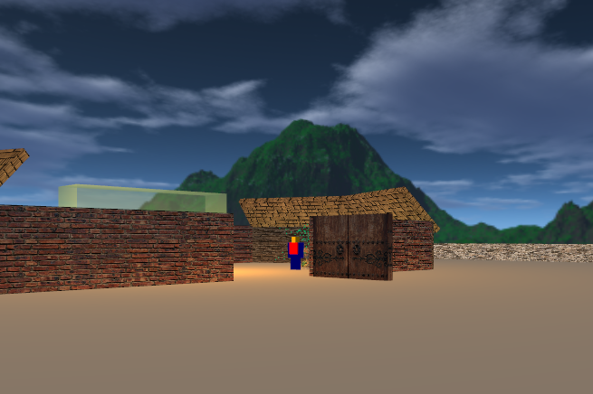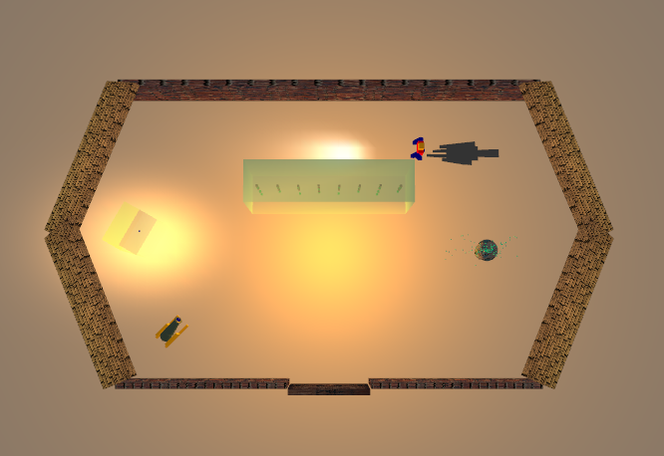

Figure 9: Top down view

Figure 8: Outside, rotating door and skybox

**Features – plus extra**

1. **Skybox:** The whole cube scene is textured with textures given to us by the University of Canterbury. The actual museum scene is in the middle of the cube. This results in the edges of the cube to be invisible to the eye. (see fig 8)
2. 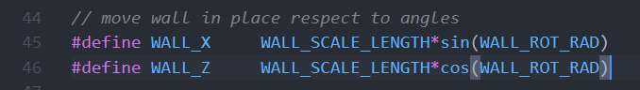**Door:** The door is textured with textures from <https://www.textures.com/> all the ways round with a modern look – Extra feature.
3. 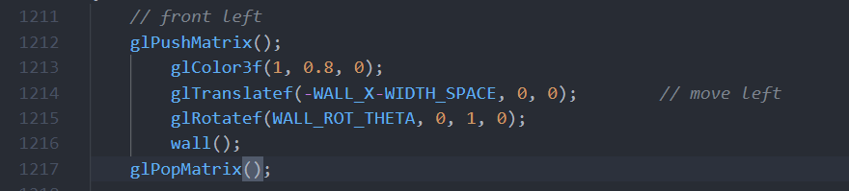**Building(Walls + Roof):** Designed using a simple 13 cube made by vertex coordinates around an axis of 1. Then by using simple trig created, I created a hexagon. The same Trig concept was also use with the roof. This is shown in (fig 9 above) – Extra feature.

Example of front left wall transformed using Trig movement

1. 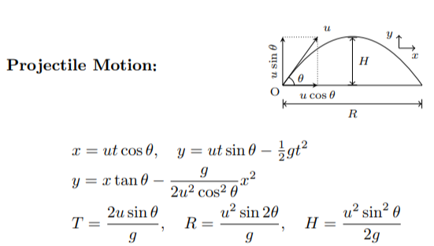**Cannon:** Designed using glut objects.

.off file used from lab 2. When triggered, Cannon fires a sphere and moves in an arc shape by using projectial motion formulas (as sgown to the side) – sphere has collision detection with glass wall. (see fig 3)

1. 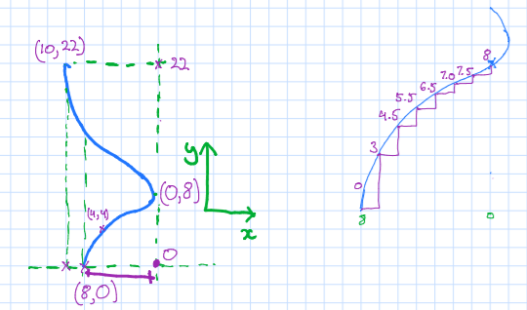**Fountain (Custom built):** The fountain model was designed by using object modelling – sweep surfaces technique from lab 4 and 5. (see figs below). The texture used

https://en.wikipedia.org/wiki/Projectile

Fountain designed on tablet

on this surface was from

<https://www.textures.com/>

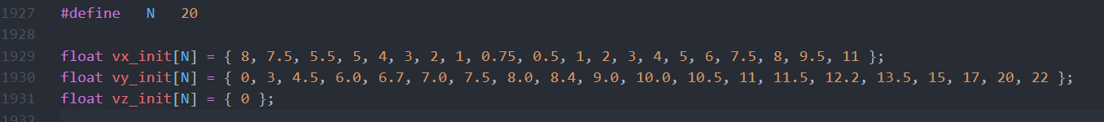(see fig 4)

Base plot – Model drawn in increments of 3.6o

1. **Particle System:** Water particles are shot off randomly in the 3d-plane. Gravity is applied to these to get a realism effect i.e.(curved shape). Projectile motion formulas used. There is a

max number of particles that can be generated at every interval. The cycle of a particle is, Init at the start then loop through -> live -> die. At the end of die reset that same particle from the start. (see fig 4)

1. **Magic Ball - Challenge:** This ball can transform and reset to a different radius and mass size each loop.

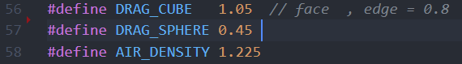The V_Terminal(…) macro determines how much friction will be added to the system as the object collides. (see fig 5) (extra – physics based animation)

**Terminal Velocity**

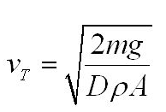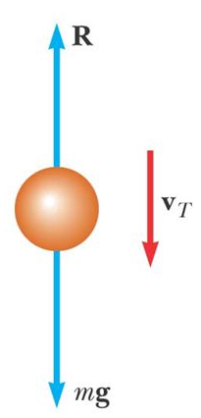

1. **‘Gravitational less’ Cabinet - Challenge:**

Fig 2 is the centre of attraction with 0 gravity and collision detection between each cube in the 3 -axis. When Trigged by glass breaking as shown in fig 7. The Terminal velocity and projectile motion formula’s are applied to each cube. This is implemented in the same way as the magic ball (above). The scene resets when a certain all objects are partially/fully stationary. – Multi/hyper threaded using pthread library for Linux. (disabled for Windows) (extra – physics based animation)

m = mass g = gravity(9.81) D = drag coeff p = air density A = object area

When the cannon ball hits the cabinet, the alpha value animates to value to 0. When alpha value = 0. (cabinet has been hit)

Physics Uni Level 1 - Text book

1. **Lighting and Shadow:**
2. Room lighting = Lighting for the whole room at the centre. (warm orangey white color)
3. Magic ball spotlight = A high contrast spotlight is displayed to the left. (as you walk into the room)
4. Flashlight = Made from a spot light directed at an angle relative to the guard’s position.
5. Guard shadow = Shadow of the guard on the floor by using the Transformation Matrix.
6. ​**Two camera modes​:**
7. First person camera is the main camera to walk around the scene. (see fig 1)
8. Top-down-view shows everything happening in the museum. (see fig 9 ) – Transforms whole scene around camera.

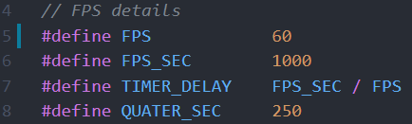

1. **FPS Counter – Extra feature:**

This counter keeps track of the whole scene speed as shown ->

Using the glutTimerFunc(..) I set the FPS of the whole scene to “60" fps.

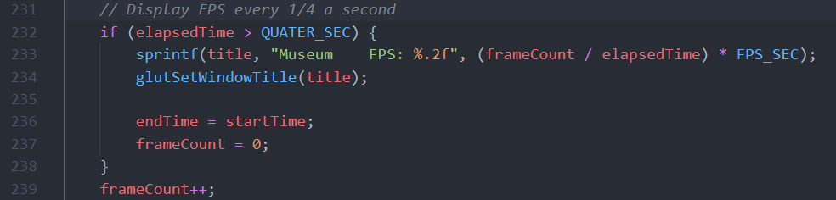

1. **Collision Detection:**
2. Collision detection between the 3rd person camera (person) and the outside scene walls.
3. Collision detection in Magic Ball (part 7)
4. Collision detection in 8x8 cube array (part 8), Both collision detection between each cube in their column and the floor



8x8 (part 8) 3D - box collision detection

**Control Functions**

1. **V/v:** Toggle between the two cameras .

* When top down view => use the “**+**” and “**–**“ keys to adjust zoom.

1. **D/d:** Toggle front door to open/close.
2. **“Space bar”**: Fires the Cannon ball from the cannon.
3. ↑: Move the general camera forward.
4. ↓: Move the general camera backward.
5. ←: Turn the general camera left by 5 degrees.
6. →: Turn the general camera right by 5 degrees.

**Program Development:**

* Platform tested (OS) = Windows and Linux
* IDE = Visual studio code
* Multi-threaded for Linux, this feature is disabled in Windows (only use 1 core)
* Linux part 8 the “Gravitational less” cabinet has 2 worker threads to create the 8x8 for cubes and 2 worker threads for detecting collisions between each of them.

**Build/Compile and run:** (Inside the Museum folder)

* **Linux** = cd Linux && make && make

“run 0 – disabled threaded if computer has less than 2 cores” or

“run 1 – enables multithreading”

* **Windows** = cd Windows && make && make run
* **Note**: Do Not enable multithreading for CPU’s with less than 2 cores (4 threads)